**Rev. Claire Matheny Bio**

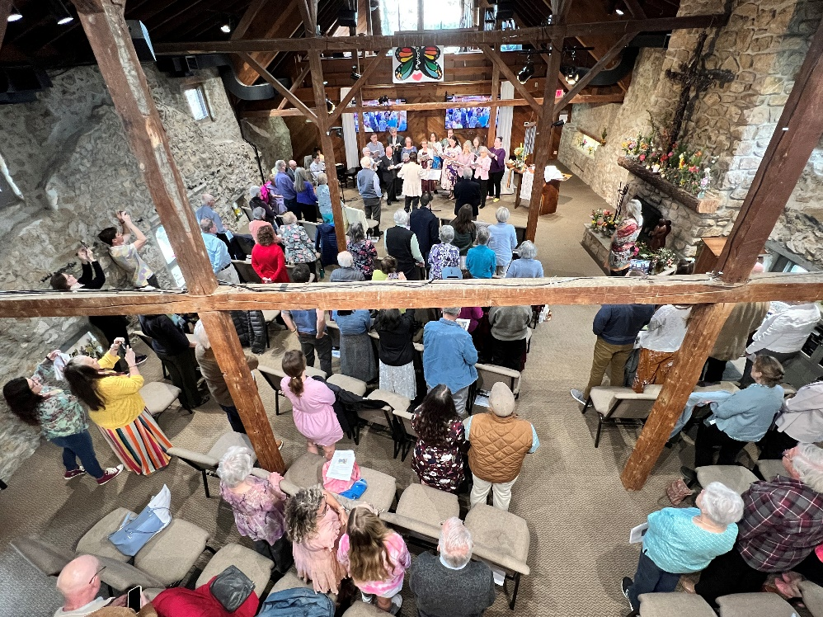  
**Rev. Claire Matheny has served at KC since 2018. She is a fourth generation United Methodist pastor from Memphis, Tennessee. She holds a Master of Divinity degree from Garrett-Evangelical Theological Seminary and a Master of Social Work degree from Loyola University of Chicago.**



**Claire has a heart for social justice, pastoral care, interfaith connections and creative worship. She relishes quiet space when she can find it.**

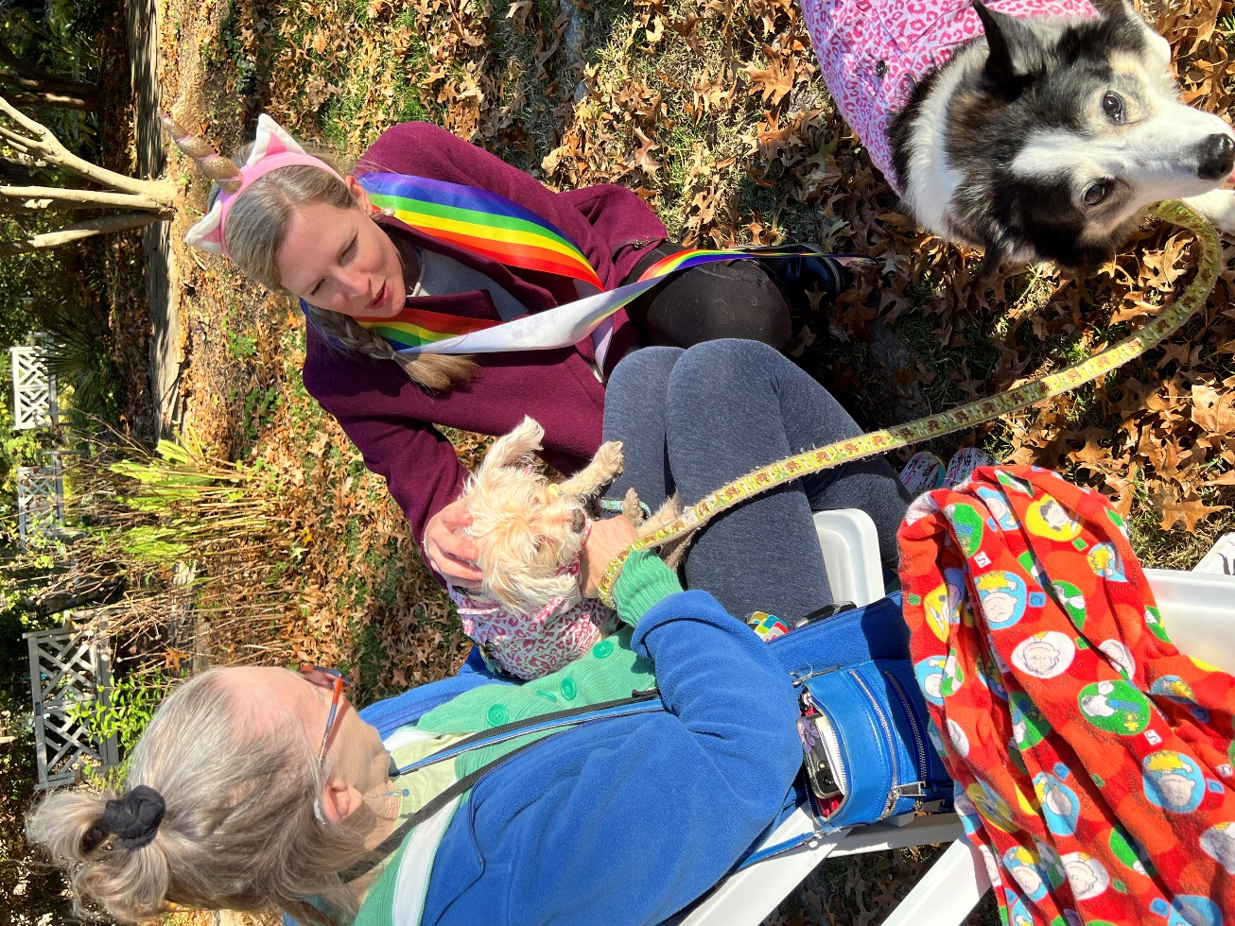

**She is married to Adam and they run around after two active kids and a dog who thinks he is a kid.**

**The people of KC keep Claire on her spiritual toes as they laugh, pray and protest their way forward together, putting Christ's love into action right now.**